User Guide for Toscana to Trias Converter

This is a user guide for a program that extracts triadic contexts from Toscana data (csx schema file + database). The triadic contexts are stored in files with the following format: on each line there should be a triple (elements separated by a specific separator, see details below) representing an element of the ternary relation specifying the context, so the context is defined by enumerating all elements of the ternary relation.

**IMPORTANT:** There must be a *schema.csx* file in the working directory. Both the database information and the scalings will be extracted from this file.

Upon launching the program a window such as the one in Fig. 1 is shown.

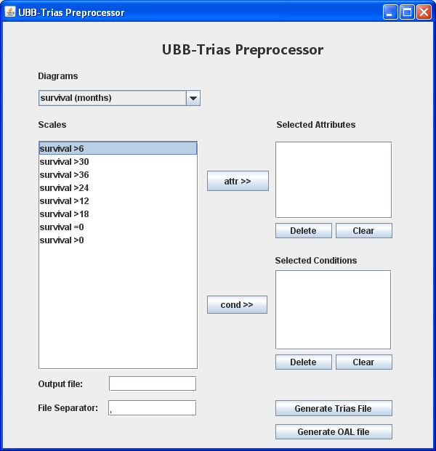

Figure

The program can be used either to generate a triadic context to be used in Trias to mine concepts or concept neighborhoods, or to generate an Object-Attribute-List (oal) file the can be used in conexp for mining association rules. Below we present the elements of this window.

* **Diagrams:** This combo box can be used to select the Toscana diagrams (scalings) from which attributes can be chosen.
* **Scales:** Contains the attributes for the current scaling (diagram). By selecting attributes in this list and then pressing *attr>>* or *cond>>* they can be added to the list of selected attributes or conditions respectively.
* **Selected attributes:** The list of all selected attributes (the ones which will be attributes in the triadic context). The *Delete* button below deletes all attributes in this list that are selected at the time. The *Clear* button deletes all attributes in the list.
* **Selected conditions:** The list of all selected conditions (the ones which will be conditions in the triadic context). The *Delete* button below deletes all conditions in this list that are selected at the time. The *Clear* button deletes all conditions in the list.
* **Output file:** The path of the file where the output (trias file or conexp oal file) will be saved.
* **File separator:** This applies only to trias files. It represents the separator of the three elements. The separator can be any string. Be advised that the elements must not contain the separator or the file will not be usable in trias.
* **Generate OAL file:** Generates an oal file for the context which has the selected attributes and conditions. The ternary relation is created based on the data in the database. In the oal file, the objects are the *(objects x attributes)* of the triadic context and the attributes are the *conditions* of the triadic context.
* **Generate Trias file:** Generates a file having the specified format readable by trias: on each line there should be a triple (elements separated by a specific separator, see details below) representing an element of the ternary relation specifying the context, so the context is defined by enumerating all elements of the ternary relation.

**IMPORTANT:** For now, the program can only be used for the cancer registry database, because it depends on the key in the table having the format “*\*.\**” where the part before the dot is the actual object identification and the part after the dot is used to make several instances of the same object unique. This could be extended however by changing the code (the method *processedId* in the OALFileGenerator and TriasFileGenerator classes) or any database could be addapted to match our standard defined above.